Outings and Events, June 2005
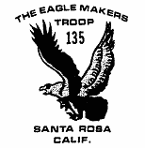
5/28-30* Lava Beds Trip
6/6 Court of Honor
6/19-24 Junior Leadership Training
6/21* Committee meeting
6/23* Outdoor meeting
6/25-26* Canoe trip
7/17-23 Scout Camp
7/29-8/14 Yosemite Long Trip
8/6-8/14 Yosemite Short Trip
9/2-9/5 Trinity Alps Trip

* new date

May Outdoors: The Scouts ventured north to the Lava Beds National Monument over Memorial Day weekend. Apparently the beds were not as comfortable as the advertisements would suggest because no one slept on them. One might have guessed this beforehand since lava is made of rock. It was also reported to be very dark inside the lava tubes, which are of course like tunnels through solid rock. This is not terribly surprising, since rock is impermeable to light and a tunnel is merely a hole on its side.

Youth Protection: Are you an adult? Do you have youth protection training? Want to win a brand new automobile? Complete the 45-minute online training found at this link

www.recbsa.org

You may choose the make and model of your new car after successful completion of the training. If there are any problems, see Mr. Lake, he can explain everything.

QMM Update: Bob Owen, the Quartermaster Master, has announced he will go back into the closet when the arbor in his back yard is completed. Apparently the plans had to be redrawn before the city would issue a permit, but it has all been cleared up and the light is green. Heavy equipment moves in this week. Tickets may be purchased at Ticketron.

New Librarian: Brett "Buff" Borell has volunteered to be the troop librarian even though he does not wear glasses and is the owner of a deep, masculine voice. He agreed to take inventory of the merit badge books to see if we need to buy any more. His plan is to see if he can bench-press the entire collection at once. If so, it is time to buy more merit badge books. Don't forget to return all the troop merit badge books so the test will be fair.

Canoe Trip: The canoe trip has been moved to June 25-26 so that it may be adequately planned during the June 13 meeting. Part of the planning involves staying afloat, and fortunately for us several adults have been trained in this area. See a related story under Adult Training.

SPL News: Anthony Holtz reported he only has 3 wisdom teeth. That might explain a few things. The younger Scouts seemed concerned when he stated he was going to have them pulled out, a decline in wisdom from 75% to 0%. Hopefully he will wait until after the Yosemite trip, since he is part of planning that one.
The Wisdom of Bob: Question: who was Chief Scout Citizen in 1910? Answer: Theodore Roosevelt. Mr. Ormond thought you might like to know this.

Adult Training: Yes, the rumors are true. Several adults have been trained, which is good since we were running short in that department. Some breathed into plastic dummies (CPR) and some watched some cheesy videos (Safe Swim Defense and Safety Afloat) and some did both. As a result the troop is now ready for the CPR Triathlon and Committee Challenge to be held in June, where we expect to dominate the swim defending and afloating events.

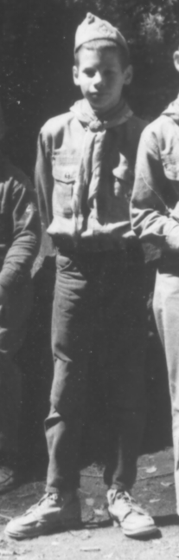
May Mystery Scout: Although there were several votes cast in favor of perennially popular Bill Cumming, the May mystery Scout is actually Mr. Ryall as he appeared in January 1967. Check out those boots. Big feet for a midget.

And we have a winner: Incredibly, for the second month in a row someone guessed the Mystery Scout. Again it was a relative, this time in reverse of last month where a parent accurately guessed her own child. James Ryall in this case correctly identified his father. Relatives are of course ineligible for the cash prizes.

Mystery Scout of June: This month we think to try something different, more in the way of a challenge, since we had two identifications in as many months. To increase the difficulty level so that you don't feel cheated after having so easily figured correctly, for June you must identify the Mystery Scout before we have actually selected one.

Canadians in the News: In a continuing series involving our friendly northern neighbors, a Canadian peanut brittle was encountered in Santa Rosa recently. Canadian peanut brittle differs from the American version in that it speaks both French and English, although it prefers to converse in the latter. When this package was queried as to whether it knew Bill Cumming, it replied it had heard of him but never met him. Alas, it was eaten before it had the chance.
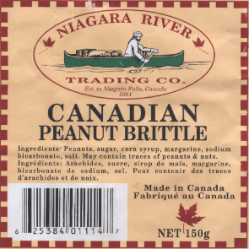
Newsletter:

Insider info by J Ryall

Additional reporting by B Cumming and
M Borell

Bilingual dessert by
H Ryall

Editing by R Ryall.

Fabriqué au USA

